PROGRAM

String Quintet No. 2 in
C minor K40

- Allegro
- Andante
- Menuetto
- Allegro

Intermission

W.A. MOZART
(1756-1791)

String Quintet in Eb flat,
Op. 97 No.3.

- Allegro non tanto
- Allegro Vivo
- Larghetto
- Finale, allegro giusto.
- DVORAK
(1841-1904)

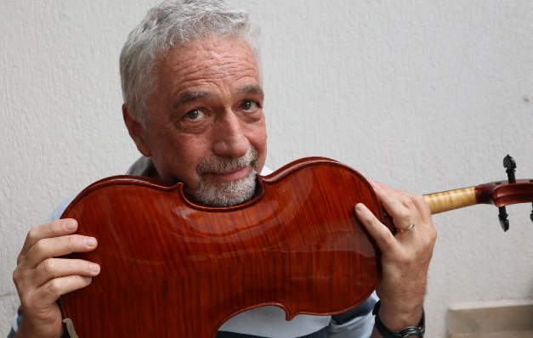
EMERSON DE BIAGGI – DMA, violist
Earned his Bachelors degree at the University of São Paulo in 1988 and was a member of the São Paulo City Orchestra from 1988 to 1990. In 1990 moved to the USA, with a scholarship from the Brazilian Government, where he studied with Raphael Hillyer and Steven Ansell at Boston University, finishing his Master’s degree in 1992. He also won a full scholarship for the DMA program at the University of California, Santa Barbara, studying with Heiichiro Ohyama, Donald McInnes and Ronald Copes. As a member of the Young Artists String Quartet, the string quartet in residence at the music department, he performed concerts in the USA, England and Brazil. After completing the DMA, he returned to Brazil in 1997, joining the São Paulo State Symphony Orchestra from 1997 to 1999. He was also principal viola player both at São Paulo Chamber Orchestra and Unesp Chamber Orchestra from 1999 to 2001. Since 1998, has been teaching viola and chamber music at Unicamp, São Paulo State University. An active chamber player, De Biaggi takes part in various ensembles, e.g. the Trio Camaleon (string trio) and the “Quintal Brasileiro” (string quintet), each with emphasis on different periods and styles. He also teaches at various of the main Music Festivals in Brazil. As soloist, has performed with orchestras all over Brazil, mostly presenting pieces from the contemporary Brazilian repertoire for viola.
A founding member of the Brazilian Viola Society, was recently elected its president for the 2022-2024 mandate.

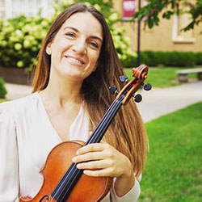
ROSSANA CAUTI, Italian-Brazilian violist Rossana Cauti enjoys a musical career that spans through Europe, Latin America, United States. A versatile musician, she is an active soloist and chamber musician, a dedicated teacher, and a frequent orchestral performer. Dr. Cauti is the Assistant Principal Viola of the Pensacola Symphony and Northwest Florida Symphony Orchestras and the Executive and Artistic Director of the International Chamber Music Festival “Suoni d’Abruzzo” (Italy).

A passionate chamber musician, Dr. Cauti is regularly invited to perform and teach in international chamber music festivals such as “Estate Musicale Frentana” (Italy), “Festival Settembre in Musica” (Italy), “The Southern Illinois Music Festival” (USA), “International Chamber Music Festival Del Garda” (Italy), “New York Summer Music Festival” (USA), “Festival de Musica de Campinas” (Brazil).
She collaborates and performs with world-renowned artists such as Yulia Berinskaya (Milano Music Master School), Andrea Massimo Grassi (Accademia del Teatro Alla Scala), Marco Fiorentini (Ars Trio di Roma), Frieder Berthold, Andrej Kurti (Northwestern State University), William Cernota (Chicago Lyric Opera).
She recently won positions as Assistant Principal Viola for Pensacola Symphony, Northwest Florida Symphony Orchestra, Tallahassee Symphony Orchestra. She previously served the Jacksonville Symphony as Section Viola, and the Florida State University Symphony Orchestra as Principal Viola.
Before moving to the USA in 2016, Dr. Cauti has worked as Principal Viola for “Pergolesi Spontini” Orchestra (Italy), Orchestra da Camera di Lugano (Switzerland), Orchestra “A. Vivaldi” (Italy), Orchestra Sinfonica da Unicamp (Brazil), touring Europe, Asia, South America, and performing in all major concert halls of Italy.
As a Viola faculty, she has taught for the New York Summer Music Festival, the Southeast Missouri Chamber Music Institute, Festival Suoni d’Abruzzo (Italy), Cives Mundi Academy (Switzerland), Southern Illinois University Carbondale, Southern Illinois Chamber Music Institute. She has given masterclasses in USA, Italy, Brazil, Mexico, Switzerland and she is currently working on publishing her own pedagogical work on Bela Bartók’s Concerto for Viola and Orchestra.
Dr. Cauti is a graduate of Florida State University (D.M.), Southern Illinois University (M.M.), Pescara Conservatory in Italy (A.D. and B.M.), Lugano Conservatory in Switzerland, Accademia Internazionale di Musica di Roma and at the Accademia del Garda in Italy.
Among her main viola professors and mentors are Yuval Gotlibovich (Lugano Hochschule fur Musik), Luca Ranieri (RAI Principal Viola), Marco Fiorentini (Ars Trio), Pamela Ryan (Florida State University).
She has performed in masterclasses with Maxim Rysanov, Toby Appel, Heidi Castlemann, Misha Amory, Csaba Erdélyi, Jon Thorne, Alexander Zemstov, Albert Igolnikov, Simonide Braconi, Massimo Paris, Ivan Vukcevich.

She plays on a Thomas Meuwissen Viola (2011) from Brussels, Belgium.
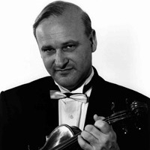
Violinist, MICHAEL BARTA, studied at the Franz Liszt Academy in Budapest, Hungary and received his degree with highest honors. He was chosen concertmaster of the World Youth Orchestra in 1971 under Karel Ancerl. In 1973 he won the 2nd prize at the Joseph Szigeti International Competition in Budapest and the Gold Medal of the Ysaye Society in Brussels, Belgium. In 1974 he received a prize as Finalist of the Tchaikovsky International Competition in Moscow, Russia. He held the title Soloist of the National Philharmony in Hungary and was first violinist of the Kodály String Quartet. In the United States he became professor of violin at Central Michigan University. Since 1985 he serves as Professor of Violin and Chamber Music at Southern Illinois University at Carbondale. Mr. Barta has performed in 32 countries, including most of Europe, China and Japan. He performed at such venues as Carnegie Hall and Alice Tully Hall in the United States, Wigmore Hall and Queen Elizabeth Hall in London, Radio France in Paris, and many others. He recorded on the Hungaroton, Serenus and Melodia labels and at the Scottish BBC in Edinburgh, Radio France, Radio Bremen, Sender Freies Berlin, Südwestfunk. He served on the summer faculty of the Central Catalonia Music Festival and Academy and the Festival of the Pyrenees in Spain and regularly teaches masterclasses at conservatories in Hungary, Bulgaria, Italy, Malta, Latvia and Austria. He is co-founder of the Southern Illinois Chamber Music Society, and also performs as the Assistant Concertmaster of the Illinois Symphony and Chamber Orchestra and as Concertmaster of Sinfonia da Camera in Champaign-Urbana, Illinois under the direction of Maestro Ian Hobson.

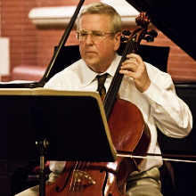
WILLIAM CERNOTA, violoncello, has been a member of the Chicago Lyric Opera Orchestra since 1982. Since 1994 he has been a member and Chair of the Lyric Opera Orchestra Members Committee. From 1982 to 1996 he was a substitute cellist with the Chicago Symphony Orchestra. While a student of Chicago Symphony Principal Cellist Frank Miller, he was Principal Cellist of the Chicago Civic Orchestra where he performed as soloist in Richard Strauss’s Don Quixote and Ernest Bloch’s Schelomo. He has also been Principal Cellist of the Chicago Chamber Orchestra, Concertante di Chicago, Chicago Opera Theater, Peninsula Music Festival, and is currently Principal Cellist of the Southern Illinois Music Festival.

He has performed annual recitals since 2011 on international broadcasts from WFMT Chicago with pianist Eric Weimer. He was a soloist on two European tours of the Chicago Chamber Orchestra and is a member of the music faculties at Loyola University Chicago and Southern Illinois University Carbondale.

Following graduation in Ideas & Methods and Biology from the University of Chicago, he served three years in the Peace Corps, Sierra Leone as a biology teacher and band director. He appears in contemporary music concerts and has also performed on baroque cello. He performed Witold Lutosławski’s works for solo cello at Orchestra Hall, Symphony Center in Chicago with the composer in attendance.

With pianist Joy Doran, he issued a CD: On or About December 1910. He also works as a research scientist at Fermalogic Incorporated in Chicago and completed the Masters in Engineering Degree at University of Illinois Chicago. He resides in Chicago with his wife Maria, daughter Naomi, and cellist son-in-law Aleksei.

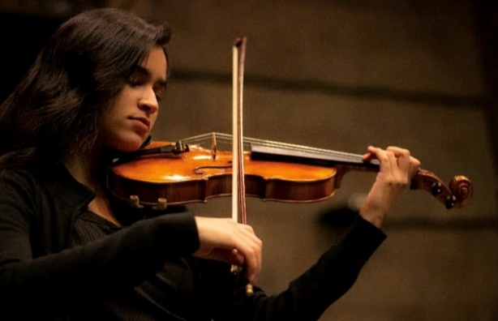
In 2012, IASMIM BONFIM began her violin studies with professor Derik Costa at AEB Social Project, in São Paulo, Brazil. Later, she joined the Municipal Music School of São Paulo, under Ricardo Takahashi's instruction until July 2023.
In 2022 she got a Bachelor of Music Education degree, from FMU/FIAM-FAAM in São Paulo.
In 2021, she was one of the winners of the Mozarteum Cadenza contest.
From 2021-2023, she was fellow of five orchestras in São Paulo, such as Jovem Tom Jobim, Jovem do Theatro São Pedro, Acadêmica Mozarteum Brasileiro, Orquestra de Câmara da USP, and Experimental de Repertório.
From 2022 to July 2023 she was the violin teacher of Santo Americo School of Music.
She's currently pursuing her Master in Music-Performance under Professor Barta's instruction at SIU.

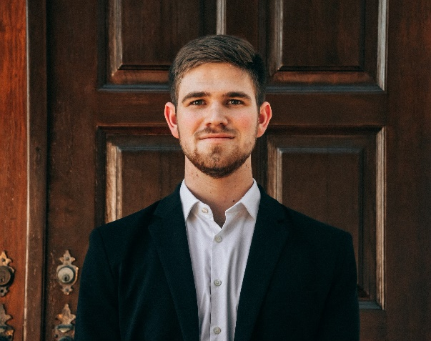
Born in Midland, Michigan, NOAH BROWN is a violist working on his graduate
performance degree at Southern Illinois University in Carbondale. He is currently studying viola under the direction of Dr. Rossana Cauti. Noah has had the privilege to perform in master classes for both the Pacifica Quartet and the Dover Quartet. While earning his undergraduate degree from Pensacola Christian College, Noah competed as a finalist in the John Leatherwood Concerto Competition. He also performed as a section violist in the Northwest Florida and Panama City Symphony Orchestras. Noah currently performs in ensembles in the Southern Illinois region.

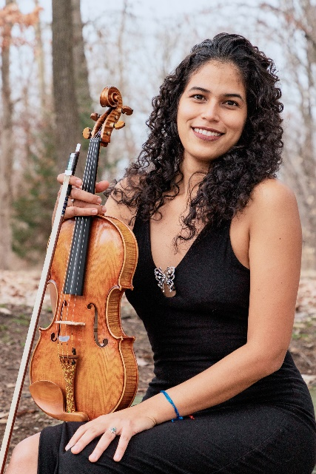
MARIA DEL MAR AÑASCO MINA is a Violist from Cali, Colombia. She began her music studies in the Antonio María Valencia Conservatory in Cali. She obtained her bachelor’s degree in Viola Performance from the Universidad del Valle in 2019. In 2012, she participated in "La Via dei Concerti" doing tours in countries like Italy, France, and Spain. She was supernumerary in the Cali Philharmonic for several years and participated in concerts with the Symphony Orchestra of Colombia. During 2017 and 2019, she was part of the Youth Philharmonic of Colombia under the direction of Andrés Orozco-Estrada and performed in concerts with the Houston Symphony in the United States and in countries such as Germany and Austria. Between 2019 and 2022, María del Mar was a violist of the Caldas Symphony Orchestra. She is currently studying a Music master’s degree at Southern Illinois University under the mentorship of Dr. Rossana Cauti.

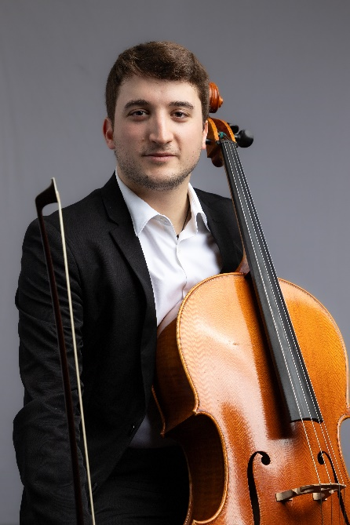
PAOLO CHIAVAROLI
A native of Pescara, Italy, cellist Paolo Chiavaroli began to study music and cello at the age of 8, and received his Bachelor’s degree in Cello Performance from the Pescara State Conservatory in 2021, as a student of Professor Massimo Magri.
He then undertook a year of studies at Spain’s prestigious Conservatory "Victoria Eugenia" of Granada, studying with Maestro Alberto Martos Lozano.
He is currently pursuing his Master’s degree in Cello Performance at SIU, studying with Professor William Cernota.
Paolo has performed in many cello masterclasses with such distinguished international cellists as Enrico Bronzi (Mozarteum University, Vienna), Albert Roman (St. Moritz, Switzerland), Michael Dmochowski (Escuela Reina Sofia, Madrid), Giuliano De Angelis and many other chamber music courses with important renowned musicians as Orfilia Saiz Vega (Granada Conservatory), Andrej Kurti, David Kim (Philadelphia Orchestra) and Igor Kalnin (Illinois State University).
During his carrer Paolo was member of different chamber and orchestral ensembles such as: Symphonic Istitution "Abruzzese", "Luisa D'Annunzio" State Conservatory Orchestra, Orquesta Conservatorio "Victoria Eugenia" de Granada, Chamber Orchestra "Benedetto Marcello", Southern Illinois Symphony Orchestra, South East Missouri Orchestra, Paducah Symphony Orchestra.

